The Parish of Christ Church
with St Mary Magdalen and St Peter and St Paul
St Leonards on Sea

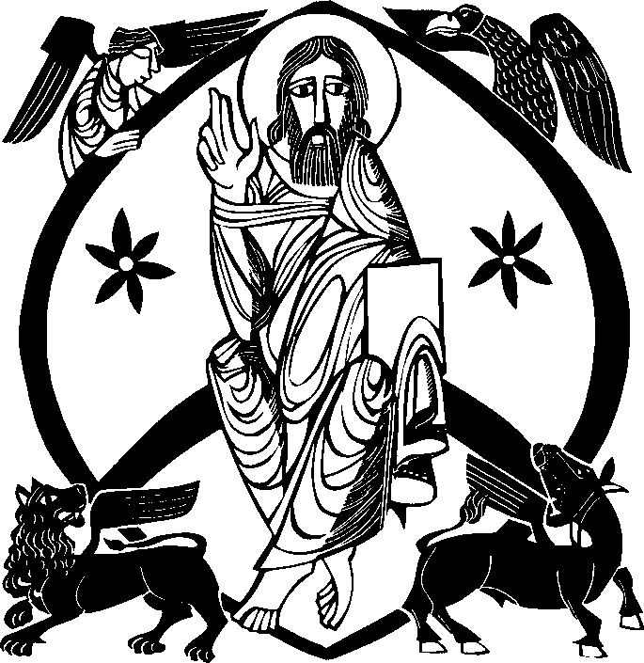

The Feast of the Transfiguration of the Lord Solemn Mass with Holy Baptism
10.30am
7th August 2022

Welcome to Christ Church. You are very welcome to join us for our worship, and
afterwards for refreshments. If you are visiting, please make yourself known to one of the clergy. If you would like to join our mailing list and keep up to date with our upcoming services and events, email christchurchmailing@gmail.com.

We are open daily from 8.30am for prayer, to light a candle or simply to visit this beautiful House of God.

This Week at Christ Church: Monday to Wednesday

Monday 8th August – St Dominic
Mass Readings: Ezekiel 1.2-5, 24-28; Psalm 148; Matthew 17.22-27 Mass Intention: The Order of Preachers (Dominicans)

9.30am – 11.30am - Parish Book Room Open 10.30am - Said Mass in the Lady Chapel
6.00pm - Said Mass in the Lady Chapel

Tuesday 9th August – Feast of St Teresa Benedicta of the Cross
Mass Readings: Hosea 2.16, 17, 21-22; Psalm 44 (45); Matthew 25.1-13 Mass Intention: Prisoners & Prison Staff

10.30am - Said Mass in the Lady Chapel
6.00pm - Said Mass in the Lady Chapel

Wednesday 10th August – Feast of St Laurence the Deacon Mass Readings: II Corinthians 9.6-10; Psalm 111 (112); John 12.24-26 Mass Intention: The sick and infirm

9.30am – 11.30am - Parish Book Room Open 10.00am - Holy Rosary in the Lady Chapel
10.30am - Said Mass including Healing Ministries in the Lady Chapel followed by refreshments
4.30pm - Reception of Christopher Goodman RIP
6.00pm - Said Mass in the Lady Chapel

This Week at Christ Church: Thursday to Sunday

Thursday 11th August – St Clare
Mass Readings: Ezekiel 12.1-12; Psalm 77 (78); Matthew 18.21 – 19.1
Mass Intention: The Poor Clares

NO 1030 MASS
1.00pm - Requiem Mass and Funeral of Christopher Goodman RIP
6.00pm - Said Mass in the Lady Chapel

Friday 12th August – St Jane Frances de Chantal
Mass Readings: Ezekiel 16.59-63; Isaiah 12; Matthew 19.3-12 Mass Intention: Those on holiday

10.30am - Said Mass in the Lady Chapel
6.00pm - Said Mass in the Lady Chapel

Saturday 13th August – St Pontian & St Hippolytus
Mass Readings: Ezekiel 18.1-10, 13, 30-32; Psalm 50 (51); Matthew 19.13-15 Mass Intention: The Cell of Our Lady of Walsingham

10.30am - Said Mass in the Lady Chapel

Sunday 14th August
The Assumption of the Blessed Virgin Mary
Mass Readings: Revelation 11.19, 12.1-6, 10; Psalm 44 (45); I Cor 15.20-26; Luke 1.39-56
Mass Intention: The Parish

8.00am - Said Mass in the Lady Chapel
9.30am - Informal Mass
10.30am - Solemn Mass & Launch of the Cell of Our Lady of Walsingham
followed by refreshments
4.00pm - CBS Vespers & Benediction

Mass Setting – Dom Gregory Murray

Entrance Hymn

- O vision blest of heavenly light, which meets the three disciples’ sight,
when on the holy mount they see their Lord’s transfigured majesty.

- More bright than day his raiment shone;
the Father’s voice proclaimed the Son
belov’d before the worlds were made,
for us in mortal flesh arrayed.

- And with him there on either hand
lo, Moses and Elijah stand,
to show how Christ, to those who see,
fulfils both law and prophecy.
- O Light from light, by love inclined,
Jesu, redeemer of mankind, accept thy people’s prayer and praise
which on the mount to thee they raise.

- Be with us, Lord, as we descend to walk with thee to journey’s end, that through thy cross we too may rise,
and share thy triumph in the skies.

- To thee, O Father, Christ, to thee let praise and endless glory be, whom with the Spirit we adore, one Lord, one God, for evermore. Amen

The Greeting

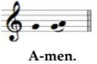
+ In the name of the Father and of the Son and of the Holy Spirit

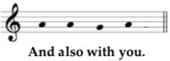
The Lord be with you.

The Celebrant introduces the Mass

The Penitential Rite

Almighty God, our heavenly Father, we have sinned against you and against our neighbour, in thought and word and deed and in what we have left undone. For the sake of our Lord Jesus Christ, forgive us all that is past and grant that we may serve you in newness of life, to the glory of your name. Amen

May almighty God have mercy on us, forgive us our sins, and bring us to everlasting life. Amen

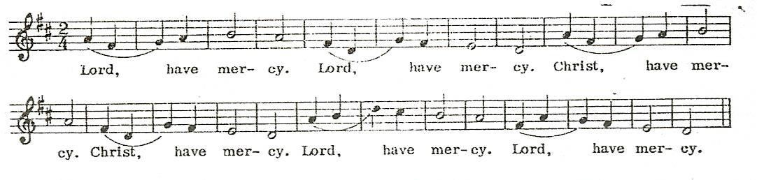
Lord have mercy, Lord have mercy Christ have mercy, Christ have mercy Lord have mercy, Lord have mercy

The Gloria

Glory to God in the highest, and peace to his people on earth,
Lord God, heavenly King, almighty God and Father; we worship you, we give you thanks, we praise you for your glory.
Lord Jesus Christ, only Son of the Father, Lord God, Lamb of God, you take away the sins of the world, have mercy on us; you are seated at the right hand of the Father, receive our prayer.
For you alone are the Holy One, you alone are the Lord, you alone are the most high, Jesus Christ, with the Holy Spirit, in the glory of God the Father. Amen

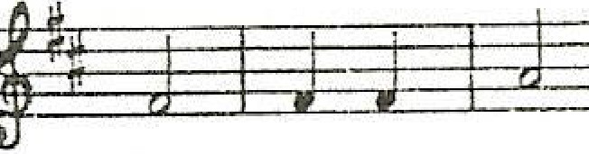Glo- ry to God in the high- est, and peace to his peo-plc on

. ,,,,

earth. Lord God, hea- ven-ly King, al- migh- ty God and
Fa- ther, we wor- ship yo, , we givr. you thanks, we praise you

for your glo- .y.
Lol'd
Je- sus Christ, on- ly
Son of the

f¥t1
.
I
El
d

±
..
J

Fa- ther, Lord
Gou
Lamb of
God, you take a- ·way the

l#ff & @¥12 ±t=ffe E.l_1¥J-U;t
1
sin of the world, have mer- r.y on us; a you are sea-tetl at the
right hand of the
Fa-
ther 1 re- ceive
our
For youa-

lone are the Ho- Iy One, you a-• lone are the lord, you a..
lone are the Most High, .Je- s11s Christ, with ti1e Ho ly Spi-rit
;-:. h@sttrr--t-rl£-t=ci-f
f---l_+-i--,+-j----,11 '-!-d-+.··
in the glo- ry of God the Fa ther. A- men.

Collect

O God, who in the glorious Transfiguration of your Only Begotten Son
confirmed the mysteries of faith by the witness of the Fathers and wonderfully prefigured our full adoption to sonship, grant, we pray, to your servants,
that, listening to the voice of your beloved Son, we may merit to become coheirs with him.
Who lives and reigns with you in the unity of the Holy Spirit, God, for ever and ever
Amen.

Please sit

THE LITURGY OF THE WORD
Daniel 7:9-10,13-14; Psalm 96 (97); II Peter 1:16-19; Luke 9.28-36

First Reading A reading from Book of Daniel

As I watched:
Thrones were set in place and one of great age took his seat. His robe was white as snow, the hair of his head as pure as wool. His throne was a blaze of flames, its wheels were a burning fire. A stream of fire poured
out, issuing from his presence. A thousand thousand waited on him, ten thousand times ten thousand stood before him. A court was held and the books were opened. I gazed into the visions of the night. And I saw,
coming on the clouds of heaven, one like a son of man. He came to the one of great age and was led into his presence. On him was conferred sovereignty, glory and kingship, and men of all peoples, nations and
languages became his servants. His sovereignty is an eternal sovereignty which shall never pass away, nor will his empire ever be destroyed.

The word of the Lord
Thanks be to God.

Psalm from Psalm 96 (97)

/R: The Lord is king, most high above all the earth.

The Lord is king, let earth rejoice, let all the coastlands be glad.
Cloud and darkness are his raiment; his throne, justice and right. /R

The mountains melt like wax before the Lord of all the earth. The skies proclaim his justice; all peoples see his glory. /R

For you indeed are the Lord most high above all the earth, exalted far above all spirits.
The Lord is king, most high above all the earth. /R

Second Reading A reading from the Second Letter of Peter

It was not any cleverly invented myths that we were repeating when we brought you the knowledge of the power and the coming of our Lord
Jesus Christ; we had seen his majesty for ourselves. He was honoured and glorified by God the Father, when the Sublime Glory itself spoke to him and said, ‘This is my Son, the Beloved; he enjoys my favour.’ We heard this ourselves, spoken from heaven, when we were with him on the holy mountain. So we have confirmation of what was said in prophecies; and you will be right to depend on prophecy and take it as a lamp for lighting a way through the dark until the dawn comes and the morning star rises in your minds.

The word of the Lord
Thanks be to God.

Please stand to sing the Gospel Acclamation.

Alleluia, alleluia, alleluia!
Alleluia, alleluia, alleluia!
This is my Son, the Beloved: He enjoys my favour. Listen to Him.
Alleluia, alleluia, alleluia!

Please turn to face the pulpit, from where the Gospel is proclaimed.

The Lord be with you And also with you.
A reading (+) from the Holy Gospel (+) according to Luke (+) Glory to you, O Lord.

The Gospel

Jesus took with him Peter and John and James and went up the mountain to pray. As he prayed, the aspect of his face was changed and his clothing became brilliant as lightning. Suddenly there were two men there talking to him; they were Moses and Elijah appearing in glory, and they were
speaking of his passing which he was to accomplish in Jerusalem. Peter and his companions were heavy with sleep, but they kept awake and saw his glory and the two men standing with him. As these were leaving him, Peter said to Jesus, ‘Master, it is wonderful for us to be here; so let us make three tents, one for you, one for Moses and one for Elijah.’ – He did not know what he was saying. As he spoke, a cloud came and covered them with shadow; and when they went into the cloud the disciples were afraid. And a voice came from the cloud saying, ‘This is my Son, the
Chosen One. Listen to him.’ And after the voice had spoken, Jesus was
found alone. The disciples kept silence and, at that time, told no one what they had seen.

The Gospel of the Lord
Praise to you, Lord Jesus Christ Homily – please sit

THE LITURGY OF BAPTISM

The celebrant invites the children, parents and godparents to the front:

Our Lord Jesus Christ has told us that to enter the kingdom of heaven we must be born again of water and the Spirit, and has given us baptism as the sign and seal of this new birth. Here we are washed by the Holy Spirit and made clean. Here we are clothed with Christ, dying to sin that we may live his risen life. As children of God, we have a new dignity and God calls us to fullness of life.

Addressing the whole congregation, he says:

Faith is the gift of God to his people. In baptism the Lord is adding to our number those whom he is calling. People of God, will you welcome
Monika & Charlotte and uphold them in their new life in Christ?
With the help of God, we will.

He then addresses the parents and godparents:

Parents and godparents, the Church receives these children with joy.
Today we are trusting God for their growth in faith. Will you pray for them, draw them by your example into the community of faith and walk with them in the way of Christ? With the help of God, we will.

In baptism these children begin their journey in faith. You speak for them today. Will you care for them, and help them to take their place within the life and worship of Christ’s Church? With the help of God, we will.

The Celebrant addresses Charlotte through her parents and godparents who answer the questions put to them, and Monika directly:

In baptism, God calls us out of darkness into his marvellous light. To follow Christ means dying to sin and rising to new life with Him.

Therefore I ask:

Do you reject the devil and all rebellion against God?
I reject them.
Do you renounce the deceit and corruption of evil?
I renounce them.
Do you repent of the sins that separate us from God and neighbour?
I repent of them.
Do you turn to Christ as Saviour?
I turn to Christ.
Do you submit to Christ as Lord?
I submit to Christ.
Do you come to Christ, the way, the truth and the life?
I come to Christ.

The Celebrant makes the sign of the cross with the Oil of Baptism (Catechumens) on the foreheads of the candidates:

Christ claims you for His own. Receive the sign of His cross. Do not be ashamed to confess the faith of Christ crucified.

All say: Fight valiantly as a disciple of Christ against sin, the world and the devil, and remain faithful to Christ to the end of your life.

May almighty God deliver you from the powers of darkness, restore in you the image of his glory, and lead you in the light and obedience of Christ. Amen.

The baptism party move to the font; all are welcome to join us and gather around the font – please follow the procession.

Blessing & Invocation of God over the Baptismal Water

Praise to you, almighty God and Father, for you have created water to cleanse and give life.
Blessed be God.

Praise to you, Lord Jesus Christ, the Father’s only Son, for you offered
yourself on the cross, that in the blood and water flowing from your side, and through your death and resurrection, the Church might be born.
Blessed be God.

Praise to you, God the Holy Spirit, for you anointed Christ at his baptism in the waters of Jordan, so that we might all be baptized into you.
Blessed be God.

You have called your children Monika & Charlotte to this cleansing water that they may share in the faith of your Church and have eternal life. By the mystery of this consecrated water lead them to a new and spiritual birth. We ask this through Christ our Lord.
Amen.

The Celebrant addresses the congregation:

Brothers and sisters, I ask you to profess together with this candidate the faith of the Church.

Do you believe and trust in God the Father?
I believe in God, the Father almighty, creator of heaven and earth.

Do you believe and trust in his Son Jesus Christ?
I believe in Jesus Christ, his only Son, our Lord, who was conceived by the Holy Spirit, born of the Virgin Mary, suffered under Pontius Pilate, was crucified, died, and was buried; he descended to the dead. On the third day he rose again; he ascended into heaven, he is seated at the right hand of the Father, and he will come to judge the living and the
dead.

Do you believe and trust in the Holy Spirit?
I believe in the Holy Spirit, the holy catholic Church, the communion of saints, the forgiveness of sins, the resurrection of the body, and the life everlasting. Amen.

The Celebrant pours water over the heads of the candidates in turn, saying:

I baptize you in the name of the Father, and of the Son, and of the Holy Spirit.
Amen.

You have been clothed with Christ. As many as are baptized into Christ have put on Christ.

The Celebrant anoints the heads of the candidates with the Oil of Chrism, saying:

May God, who has received you by baptism into his Church, pour upon you the riches of his grace, that within the company of Christ’s pilgrim people you may daily be renewed by his anointing Spirit, and come to the inheritance of the saints in glory.
Amen.

The Celebrant gives each a candle lit from the Paschal (Easter) Candle, saying:

God has delivered us from the dominion of darkness and has given us a place with the saints in light. You have received the light of Christ; walk in this light all the days of your life. Shine as a light in the world to the glory of God the Father. There is one Lord, one faith, one baptism: by one Spirit we were all baptized into one body.

All say: We welcome you into the fellowship of faith; we are children of the same heavenly Father; Monika & Charlotte, we welcome you.

All return to their places, as we prepare to offer up our prayers to the Lord

Intercessions

After each petition this response is used
Lord, in your mercy
Hear our prayer.

After the final petition we entrust our petitions to the unceasing prayers of the Saints in heaven, especially to the Blessed Virgin Mary who we greet saying:

Hail Mary, full of grace, the Lord is with thee; Blessed art thou among women and blessed is the fruit of thy womb, Jesus. Holy Mary, Mother of God, pray for us sinners, now and at the hour of our death.

The Celebrant concludes the prayer, and all respond: Amen.

THE LITURGY OF THE SACRAMENT
Please sit for the offertory hymn as the altar is prepared. Please stand when the congregation is censed.

Offertory Hymn

- Lord, enthroned in heavenly splendour,
First-begotten from the dead, Thou alone, our strong defender, Liftest up thy people's head.
Alleluia, alleluya,
Jesu, true and living Bread!

- Here our humblest homage pay we;
Here in loving reverence bow;
Here for Faith's discernment pray we,
Lest we fail to know thee now. Alleluia, alleluia,
Thou art here, we ask not how.
- Though the lowliest form doth veil thee
As of old in Bethlehem,
Here as there thine angels hail thee,
Branch and Flower of Jesse's stem.
Alleluia, alleluia,
We in worship join with them.

- Paschal Lamb, thine Offering, finished
Once for all when thou wast slain,
In its fullness undiminished Shall for evermore remain, Alleluia, alleluia,
Cleansing souls for every stain.

- Life-imparting heavenly Manna, Stricken Rock with streaming side, Heaven and earth with loud hosanna Worship thee, the Lamb who died,
Alleluia, alleluia, Risen, ascended, glorified!

Words G.H. Bourne Tune ST HELEN George Martin

Pray, my brothers and sisters, that our sacrifice may be acceptable to God
our almighty Father.
May the Lord accept the sacrifice at your hands, for the praise and glory of his name, for our good and the good of all his holy Church.

The Priest offers the Prayer over the Gifts, and all respond. Amen. Eucharistic Prayer
The Lord be with you And also with you
Lift up your hearts We lift them up to the Lord
Let us give thanks to the
Lord our God It is right to give him thanks and praise

The Celebrant continues with the Opening (Preface) of the Prayer of Thanksgiving at the end of which we sing the Sanctus
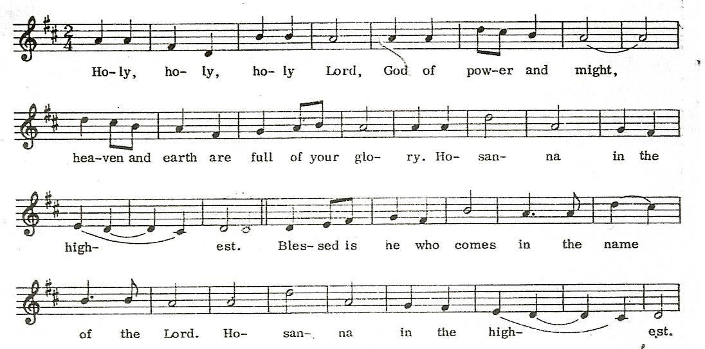

Holy, holy, holy, Lord God of power and might, heaven and earth are full of your glory. Hosanna in the highest.
Blessed is he who comes in the name of the Lord. Hosanna in the highest.

Please kneel as the Celebrant continues the Prayer of Thanksgiving.

He first invokes the Holy Spirit to sanctify the offerings of bread and wine.
He then recalls the Lord’s actions the night before he died. A bell is rung as the Celebrant elevates the consecrated Host and Chalice. He then says.

Great is the mystery of faith.
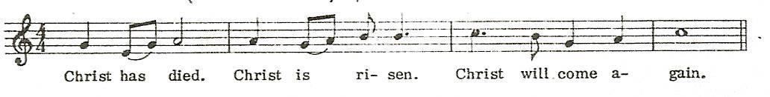
Christ has died, Christ is risen. Christ will come again.

The Celebrant continues with the Eucharistic Prayer. At the end, all respond:
The Lord’s Prayer - please stand

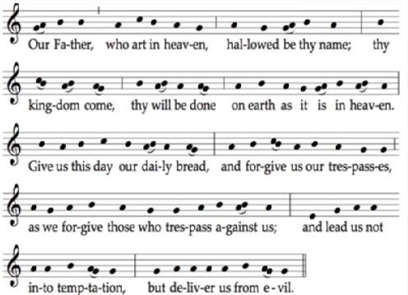
.

Deliver us, Lord, we pray, from every evil,
graciously grant peace in our days, that, by the help of your mercy,
we may be always free from sin and safe from all distress, as we await the blessed hope
and the coming of our Saviour, Jesus Christ.
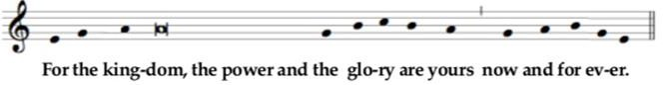

Lord, Jesus Christ,
who said to your Apostles:
Peace I leave you, my peace I give you, look not on our sins,
but on the faith of your Church,
and graciously grant her peace and unity in accordance with your will.
Who live and reign for ever and ever.

The peace of the Lord be with you always.
Let us offer each other the sign of peace.
All share a sign of peace with those near them.

Let us offer each other the sign of peace.

All share a sign of peace with those near them.

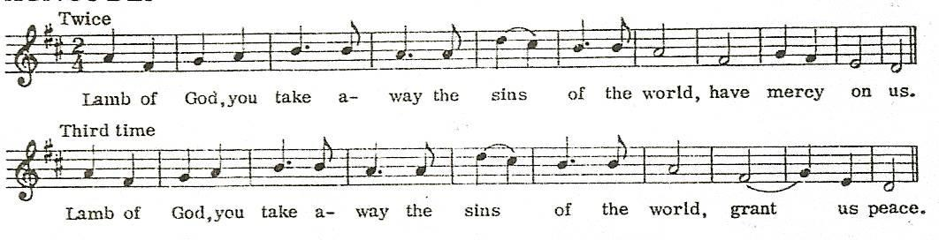
The Agnus Dei

Lamb of God, you take away the sins of the world, have mercy on us. Lamb of God, you take away the sins of the world, have mercy on us. Lamb of God, you take away the sins of the world, grant us peace.

Giving of Communion

Please kneel as the Celebrant shows the Body of Christ

Behold the Lamb of God. Behold him who takes away the sins of the world. Blessed are those called to the supper of the Lamb.
Lord, I am not worthy that you should enter under my roof, but only say the word and my soul shall be healed.

If you are confirmed, please come forward to receive Communion.
All are welcome to come forward for a blessing: if you would like one, please bow your head. Holy Communion is currently given in one form only with the words:

The Body of Christ. Amen

Please consume the Host before returning to your seat.

The Choir sing an Anthem

Communion Hymn

- Be thou my vision, O Lord of my heart,
Be all else but naught to me, save that thou art,
Be thou my best thought in the day and the night,
Both waking and sleeping, thy presence my light.

- Be thou my wisdom, be thou my true word
Be thou ever with me, and I with thee, Lord,
Be thou my great Father, and I thy true son,
Be thou in me dwelling, and I with thee one.
- Be thou my breastplate, my sword for the fight,
Be thou my whole armour, be thou my true might,
Be thou my soul's shelter, be thou my strong tower,
O raise thou me heavenward, great Power of my power.

- Riches I heed not, nor man's empty praise,
Be thou my inheritance now and always,
Be thou and thou only the first in my heart,
O Sovereign of heaven, my treasure thou art.

- High King of heaven, thou heaven's bright Sun, O grant me its joys after vict'ry is won,
Great Heart of my own heart, whatever befall, Still be thou my vision, O Ruler of all.

Words Irish, 8th century Tune SLANE Traditional Irish Melody

Prayer after Communion
Please stand.

May the heavenly nourishment we have received, O Lord, we pray,
transform us into the likeness of your Son,
whose radiant splendour you willed to make manifest in his glorious Transfiguration.
Who lives and reigns for ever and ever.
Amen.

Notices – please sit.

The Blessing and Dismissal - please stand

The Lord be with you.
And also with you

May almighty God bless you, the Father and the Son + and the Holy Spirit.
Amen

The Mass is ended. Go in the peace of Christ.
Thanks be to God.

The Angelus
The angel of the Lord brought tidings to Mary
And she conceived by the Holy Spirit
Hail Mary, full of grace, the Lord is with thee; blessed art thou among women, and blessed is the fruit of thy womb, Jesus.
Holy Mary, Mother of God, pray for us sinners, now and at the hour of our death. Amen
Behold the handmaid of the Lord Be it unto me according to thy word Hail Mary...
And the Word was made flesh And dwelt among us. Hail Mary....
Pray for us, O holy Mother of God
That we may be worthy of the promises of Christ
The Celebrant sings the collect, and all respond Amen.

Recessional Hymn

- 'Tis good, Lord, to be here! Thy glory fills the night;
Thy face and garments, like the sun,
Shine with unborrowed light.

- 'Tis good, Lord, to be here, Thy beauty to behold,
Where Moses and Elijah stand, Thy messengers of old.
- Fulfiller of the past, Promise of things to be,
We hail thy body glorified, And our redemption see.

- Before we taste of death, We see thy kingdom come; We fain would hold the vision bright,
And make this hill our home.

- 'Tis good, Lord, to be here! Yet we may not remain;
But since thou bidst us leave the mount Come with us to the plain.

Words J. Armitage Robinson Tune CARLISLE Charles Lockhart

Organ Voluntary

You are very welcome to join us for refreshments at the back of Church. If you are visiting, please make yourself known to one of the clergy.
If you would like to join our mailing list and keep up to date with our upcoming services and events, email christchurchmailing@gmail.com.
Please take this booklet home with you.

News & Notices

Please submit all notices to christchurchstleonards@hotmail.co.uk or the parish office by Wednesday PM.

Saturday Sale
Many thanks to everyone who helped with the table sale on Saturday, and indeed to all those who supported it as well.

Cell of Our Lady of Walsingham
We are re-starting the Cell of OLW at Christ Church during the 10.30 Mass on the Feast of the Assumption next week (14th August) when all current members can renew their membership, and new ones can join. Our first meeting will then be on the 20th August at 10.00am, followed by Mass and then refreshments. Forms and further information are available from Julie Gidlow, or at the back of church. The Cell is a group who will meet monthly to pray for Christ Church and our growth under the patronage of Our Lady of Walsingham; support the Shrine at Walsingham and offer support for our annual parish pilgrimage. We also intend to
organise social and fundraising events throughout the year.

Christopher Goodman RIP
Christopher will be received into church on Wednesday 10th 4.30 pm and his Funeral Mass will be on Thursday 11th 1.00 pm followed by burial in Hastings Cemetery.

Wednesday Coffee & Cake
We have now restarted our Wednesday Coffee & Cake after the 1030 Mass. All are welcome to join us every Wednesday at the back of church – volunteers & cakes very welcome too!

Healing Masses
These will re-start on the second Wednesday of the month, beginning this week on the 10th August. There will be the opportunity to receive the
Laying on of Hands, and Anointing during the Mass.

Mission Action Plan (MAP)
Please continue to submit ideas for our MAP (in writing or via email father.thomas@yahoo.com). A number of people have already made
suggestions on similar topics, which is surely a sign of the Holy Spirit at work among us. These will all be drawn together for an open meeting in the Autumn, before the final proposal is then submitted to the PCC. Please keep this process in your prayers, asking that the Holy Spirit will continue to guide us as we plan our new vision for the future together.

Appointment of a new Rector
Fr Thomas has been appointed our new Rector at Christ Church. The details of the service of Induction and Institution by the Bishop of Chichester will be announced shortly.

(G&) T with Fr T
‘Over the Summer, I’d like to spend time getting to know you all a little better – especially those I’ve not been able to spend much time with yet: if you’d like to arrange for me to visit, or to come to the Rectory for tea (or
something a little stronger!) I’ll be keeping Tuesday afternoons and evenings free. I look forward to seeing those who’ve already been in touch – if you haven’t, please do drop me a line so that we can get
something in the diary.’ Fr Thomas

Upcoming Events

Sunday 7th August – 5pm Choral Evensong
Sunday 14th August – 10.30am Mass: Launch of the Cell of Our
Lady of Walsingham
Sunday 14th August – 4pm CBS Vespers & Benediction
Friday 19th August – 10.30am & 6pm Monthly Requiem Mass
Saturday 20th August – 10.00am First Meeting of the Cell of Our
Lady of Walsingham

Parish Newsletter
Please email christchurchmailing@gmail.com to join our mailing list and keep up to date with our upcoming services and events.

For Your Prayers

From the congregation
Kathleen Hughes, Wil Jewitt, David Dawkins, Mary Ralph, Mick Hart, Jane Read, Tina Grevett

For those in urgent need
Pippa Parker, Sonia Russell, Keith Morrison, Andy Piper, Margot, Liz, Christopher Cowell, Kay Cowell, Anne Marlow, Philippa, Ruth Durrant, Brian Higgins

For those for whom our prayers are asked in the longer term Alex Farrant, Maureen Pocock, Monica Ellis, Howard Hill, Bruce McGillvray, Marley Nassey, Katie Robinson, Christine Lee, Colin
Rushforth, Hugo Rudolf, James Bradley, Tim Chappel, Jeffrey Dawson, Cameron Matheson, , Sharon Foster, Mark Lamprell, Ray Hart, Dave Darby, Barbara Childs, Brian Marlow, Arnold Kruger, Zahraan Nazir, Avan Nazir, Anastasia Nazir

THE DEPARTED

Recently departed Christopher Goodman, Jean Bryant, Gill James, Cameron Matheson, Manfred Kaczmarek

Anniversaries

7th Mabel Goldsmith
8th Gladys Mallalieu, Jeanne Lightfoot, Anna Freakes, Edward Holloran, Sheila Johnston
11th Irene Fraser, David Annison, Carlo Curley 12th Peggy Coles, Diane Robinson, Bill Hannam 13th Ian Dawkins, George Taylor

Parish Directory

www.christchurchstleonards.co.uk christchurchstleonards@hotmail.co.uk

Priest in Charge: Bishop Peter Wheatley (01424) 424814 (Email: peter.wheatley@outlook.com)
Assistant Curate: Fr Thomas Crowley SSC
H. (01424) 433220 M. 07926 528433
(Email: father.thomas@yahoo.com) Self Supporting Priest: Fr Richard Ralph (01424) 422722

Hon Asst Priests (Retired): Fr Richard Rushforth (01424) 755554
Fr David Sherwood SSC (01424) 254510

Churchwardens: Mrs Maureen Harman 0777 4044 901
Mrs Sue Shaw (01424) ) 584234
Hon Treasurer Trevor Davies (01424) 438 279

Parish Office: The Parish Centre
2 Christ Church Courtyard
St Leonards-on-Sea TN37 6GL (01424) 447 784

Safeguarding Officer: Jane Hart (01424) 716599 Assistant Safeguarding Officers: Jessica Campbell, Anne Hanney

Director of Music: David Smith 07795 550708

Find us on
Christ Church, St Leonards on Sea @ChChStLeonards
@ChChStLeonards
CCLI Licence 925696

